### **Step 1: The Need for Speed**

**Server Speedtest Results**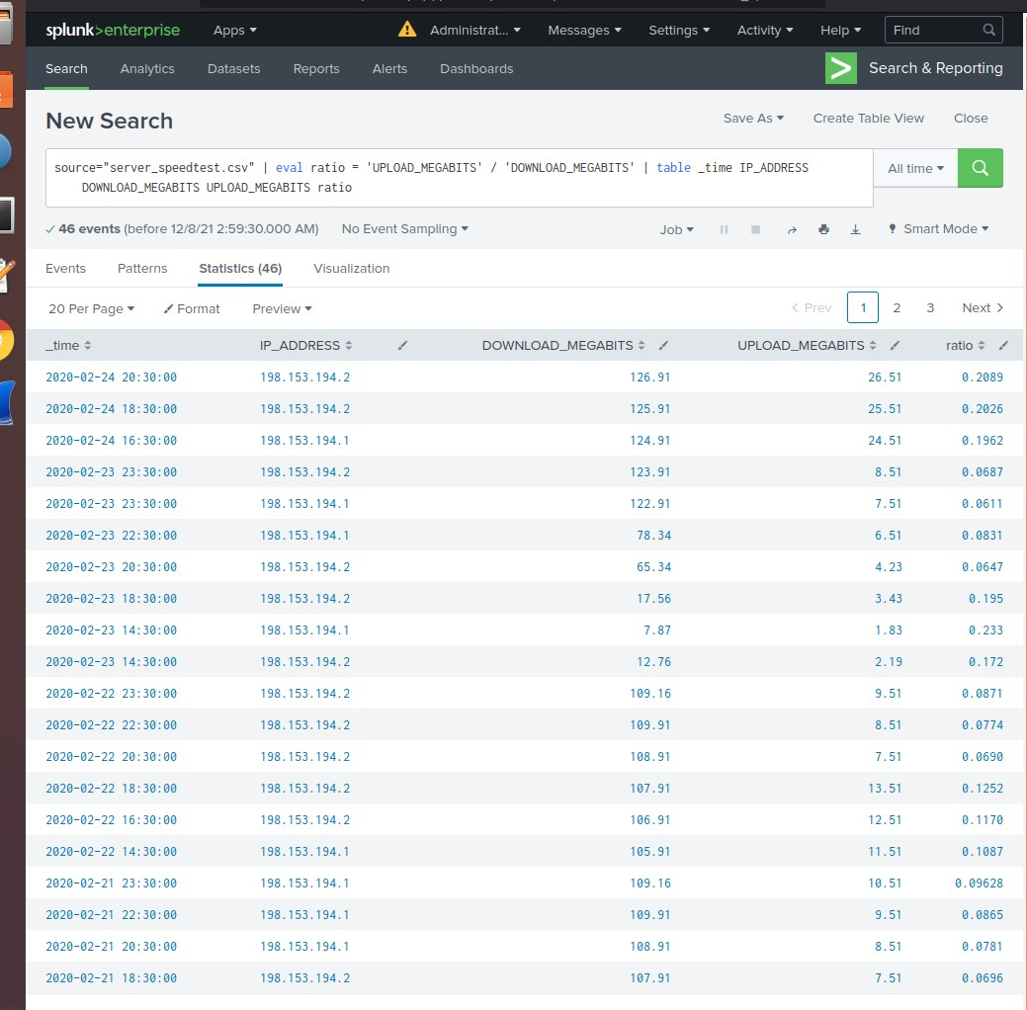

* **I have found the approximate date of the attack began on: Feb 23, 2020, and the time of the attack started at: 2:30 PM**
* **The IP Address of 198.153.194.2 was attacked**
* **The Download Megabits were 107.91**
* **The Upload Megabits were 13.51**
* **The Ratio was 0.1252**
* **It took 9 hours to recover, with a return to baseline by 11:30pm**

### 

### **Step 2: Are We Vulnerable?**

**Nessus Vulnerability Scan**

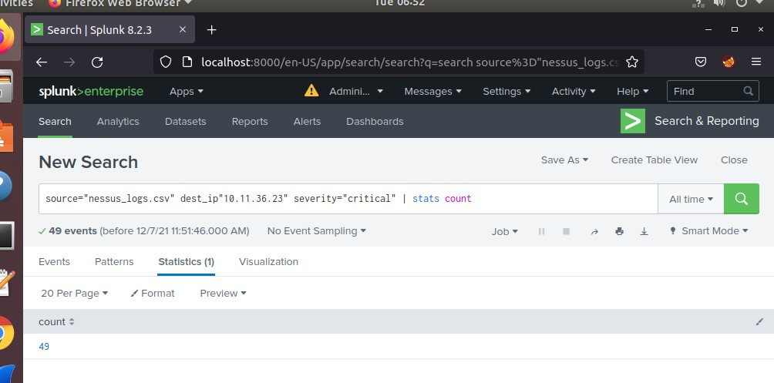

**Proof That the Alert Was Created**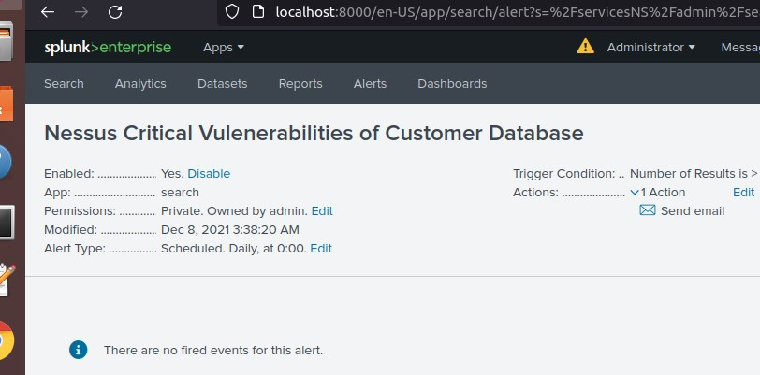

### 

### 

### 

### **Step 3: Drawing the (base)line**

**Proof That Alert Was Created**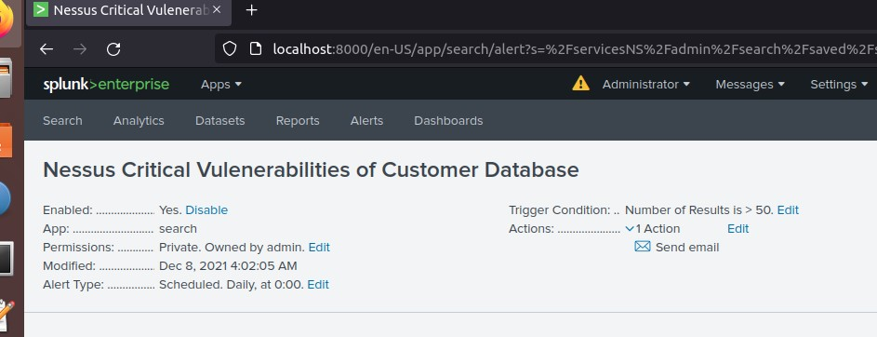

* **On February 21, 2020 there was a brute force attack**
* **It started around 9:00 AM**
* **It lasted until around 1:00 PM .**
* **A number of failed login attempts increased to between 124 to 123.**
* **The baseline of failed login attempts per hour is 25**
* **The threshold of 50 attempts per hour was triggered to cause the alert**